**BIRLA INSTITUTE OF TECHNOLOGY & SCIENCE, PILANI**

**Work Integrated Learning Programs Division**

**Post Graduate Program**

**in**

**Artificial Intelligence and Machine Learning**

**Video Analysis & Event Recognition**

CAPSTONE PROJECT

Submitted in partial fulfillment of the requirements of the

Post Graduate Certification Program

in

Artificial Intelligence and Machine Learning

By

Rajeev Kumar 2020AIML004

Jaydeep Ghose 2020AIML016

Sai Satya Chandra Edara 2020AIML063

Under the supervision of

Gautam Gangopadhyay

Project work carried out at

BIRLA INSTITUTE OF TECHNOLOGY AND SCIENCE

Pilani (Rajasthan) INDIA

(Nov 2021)

PCAM ZC321 CAPSTONE PROJECT

**Video Analysis & Event Recognition**

Submitted in partial fulfillment of the requirements of the

PGP - Artificial Intelligence and Machine Learning

By

(Rajeev Kumar, Jaydeep Ghose,

Sai Satya Chandra Edara)

(2020AIML004, 2020AIML016,

2020AIML063)

Under the supervision of

(Gautam Gangopadhyay)

Project work carried out at

BIRLA INSTITUTE OF TECHNOLOGY AND SCIENCE

PILANI (RAJASTHAN)

(Nov 2021)

**BIRLA INSTITUTE OF TECHNOLOGY AND SCIENCE, PILANI**

**CERTIFICATE**

This is to certify that the Capstone Project entitled **Video Analysis & Event Recognition**

and submitted by Mr. Rajeev Kumar, Mr. Jaydeep Ghose,

Mr. Sai Satya Chandra Edara ID No. 2020AIML004, 2020AIML016, 2020AIML063

in partial fulfillment of the requirements of PCAM ZC321 Capstone Project, embodies the work

done by him/her under my supervision.

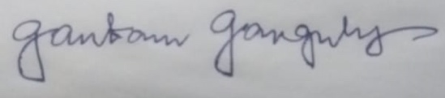

Place: Kolkata Signature of the Mentor

Date: 10th November 2021 Name: GAUTHAM GANGOPADHYAY

**BIRLA INSTITUTE OF TECHNOLOGY & SCIENCE, PILANI**

**Work Integrated Learning Programs Division 2020-21**

**PCAM ZC321 CAPSTONE PROJECT**

**Action Recognition System**

|  |  |
| --- | --- |
|  | |
| Project Title : **Video Analysis & Event Recognition**  Name of Mentor : **Gautam Gangopadhyay**  Name of Student : Rajeev Kumar, Jaydeep Ghose,  Sai Satya Chandra Edara  ID No. of Student : 2020AIML004, 2020AIML016,  2020AIML063 | Abstract This project is to automate the action recognition system based on Machine learning and Neural Network models to classify the video data. This can hence be used for automatic human activity recognition and event detection, in applications such as surveillance, entertainment and healthcare. |

**Table of Contents #TODO revisit once report is complete**

|  |  |  |
| --- | --- | --- |
| **S.No.** | **Topics** | **Page No.** |
| 1 | Problem Statement | 8 |
| 2 | Objective | 9 |
| 3 | Background | 9 |
| 4 | Business Benefits | 9 |
| 5 | Process Flow | 10 |
| 6 | Component wise Architecture | 11 |
| 7 | Project Resource | 20 |
| 8 | Potential data challenges & risks in doing the project | 21 |
| 9 | Detailed Plan of Work | 22 |
| 10 | Data Preprocessing | 23 |
| 11 | Machine Learning Modelling and Techniques | 24 |
| 12 | Code Snippet and Screen Shots | 25 |
| 13 | Interpretation | 31 |
| 14 | Conclusions / Recommendations | 36 |
| 15 | Future Work & Extension or Scope of improvements | 37 |
| 16 | Bibliography / References | 38 |

**Problem Statement**

* Computer Vision systems deal with high variety and volume of data, specifically images or videos. As a result, these systems need intricate techniques to make sense of the data and then make data driven decisions.
* The aim of this project is to create a model that can detect the basic events like swimming, jogging, soccer penally, basketball and boxing etc.
* Given a video, is it possible to recognize the action being performed in that video by an automatic system? An action recognition system is built on basic steps: first, the input video or sequence of frames; second, the extraction of low-level features from the frames; and finally, mid-level pose/gesture or action descriptions from low-level features.
* The model will be given a set of videos where in each video, a group of persons will be performing an action. The label of a video will be the action that is being performed in that video. The model will have to learn this relationship, and then it should be able to predict the label of an input (video) that it has never seen. Technically, the model would have to learn to differentiate between various events.

**Objective**

* In recent years, automatic human activity recognition and event detection have drawn much attention in the field of video analysis technology due to the growing demands from many applications, such as surveillance environments, entertainment environments and healthcare systems.
* Large amount of video in surveillance systems capable of processing video to automatically detect and recognize events. The main objective is the analysis of computer vision techniques and algorithms to predict automatic detection of specific events in video sequences

**Background #TODO do we need background again? Replace with Application? Put links related to problem statement**

* Spending on digital advertising has risen each year even as TV and print advertising declines.
* Understanding the value of digital advertising requires understanding of how value is attributed to each activity. Understanding the true worth of these channels is key to any company’s success.

**Business Benefits**

**E-commerce**: Searching and advertising is one of the mostly used use case of image recognition in E-commerce industry. Image recognition powered by deep learning can provide us advance capabilities like personalized searches, customer analytics, social media and conversation commerce, etc. With the date they got from image recognition, businesses can find insights for campaigns and marketing strategies. It is also capable to find user’s sentiments and expressions. This data will help marketers getting more return on their investments.

**Social Media**: Social media is also getting enormous benefits from image recognition. Facebook is one of the best examples of it. Facebook’s image recognition can recognize your family members and friends, identify their names and will give you suggestion to tag them while you upload picture with them. Many other social media platforms like LinkedIn & Twitter also use image recognition and object recognition features. Image recognition in social media make searches easy and effective.

**Surveillance and Security**: In surveillance and security industry, image recognition has many applications. Many big companies and security department use facial recognition to ensure security and identify crime. This process includes scanning of almost million images and adding them into deep neural networks. Then the system analyzes the images and compare them to suspects. In many cases it has proven to be very successful & effective and helped solving crimes.

**Healthcare monitoring applications**: Basically, healthcare monitoring systems are designed based on the combination of one or more AR components such as fall detection, human tracking, security alarm and cognitive assistance components. Most of the healthcare systems use body-worn and contextual sensors that are placed on patients’ bodies and in their environment. Once help is needed, the system notifies the relevant parties (i.e. medical personnel) about the situation to assist the patient quickly. The E-safe fall detection and notification system[27](https://journals.sagepub.com/doi/10.1177/1550147716665520) has used the ZigBee-based wearable sensor system to automatically detect fall situations and notify the in-house correspondents via ZigBee technology.

**Gaming**: Other than these industries, there are many sectors which are taking leverages of Image recognition and computer vision. Image recognition has several powerful applications that create a great deal. What do you think about this technology and what are the use case which you would like to cover with image recognition?  Tell us your viewpoint and let us help you out with your requirements. From identifying requirements to delivering best machine learning model, Kevitt can bring you all the benefits that come with these technologies within your business.

**Machine Learning Process Flow**

**Process Pipeline**

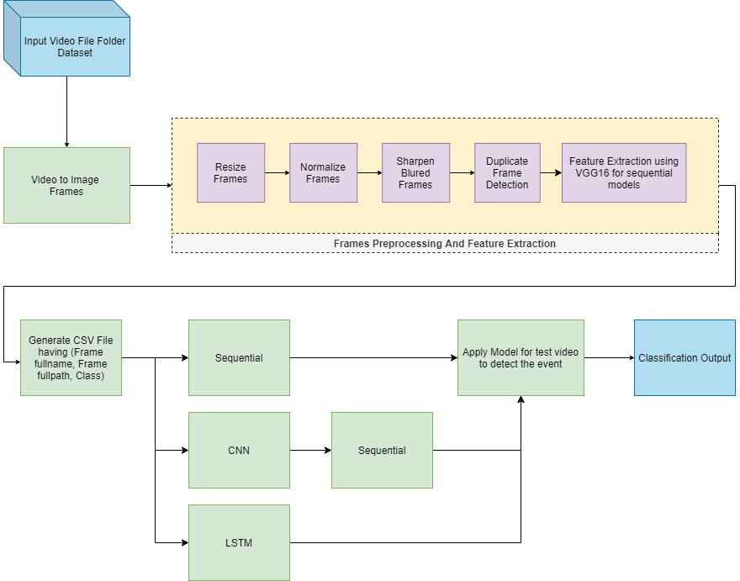

* Read video data from folder and extracting image frames from each video using CV2.
* Preprocess extracted frames to resize, normalize, sharpen blurred frame, remove duplicate frames.
* Save resulting image to folder and generate CSV with data including frame name, frame full path and class.
* Using three different models (Sequential, CNN & LSTM) and compare the results
* Use pre-trained VGG16 model without top layers for feature extraction for training sequential model.
* Out classification result for each video.

**Data Preprocessing**

In data pre-processing step we are extracting image frames from video. We are also cherry picking every fifth frame to reduce the number of frames we are using to process. We are also performing following pre-processing activities

**Resize frames:** Frames are resized to 224x224 size

**Normalize frames:** Normalize the resized frame by dividing it with 255 so that each pixel value then lies between 0 and 1

**Sharpen blurred frames:** Detect blurred image and sharpen using CV2 filter2D sharpen kernel

**Duplicate frame detection:** Call pHash method on each frame to create hash per image and compare hashes to detect duplicate images.

**Feature extraction:** In case of sequential models, we are using VGG16 model to extract features and passing them to custom sequential model.

**Component wise Architecture**

**VGG16 Model:**

VGG16 is a convolutional network model developed and introduced by K. Simonyan and A. Zisserman from Oxford Visual Geometry Group, in the year 2014, through their article “Very Deep Convolutional Networks for Large-Scale Image Recognition.”. The VGG16 model achieved 92.7% accuracy in ImageNet, which is a dataset of over 14 million images belonging to 1000 classes.

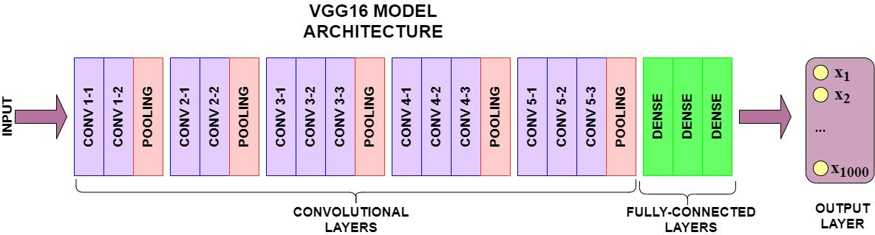

The model contains 16 layers with 5 sets of convolutional layers followed by max-pooling layers after each set and 3 fully connected layers. The input to VGG is set to an RGB image of size 224x224x3. The first two layers have 64 channels of 3x3 filter size and the same padding. This is then followed by a max-pooling layer of stride 2,2 and two more convolutional layers of 256 filter size 3,3. Another max-pooling layer of stride 2,2 is added next. After that there are 2 sets of 3 convolution layer and a max pool layer. Each has 512 filters of 3, 3 sizes with the same padding. This image is then passed to the stack of two convolution layers. There is a padding of 1-pixel (same padding) done after each convolution layer to prevent the spatial feature of the image. After the convolution and max-pooling layer stack, we get a 7x7x512 feature map. We flatten this output to make it a 1x 25088 feature vector. After this, there are 3 fully connected layers; the first layer takes input from the last feature vector and outputs a (1, 4096) vector, second layer also outputs a vector of size 1, 4096, but the third layer output 1000 channels for 1000 classes. We can set the 3rd connected layer to output an arbitrary number of classes pertaining to our use case. The last three layers are also called top layers of the model. VGG16 can also be used for just feature extraction and transfer learning. This can be achieved by excluding top layers. All hidden layers are equipped with rectification (ReLU) non-linearity, and the output layer uses SoftMax to denote the classification as a probability.

Below is the model summary that shows VGG16 layers implementation:

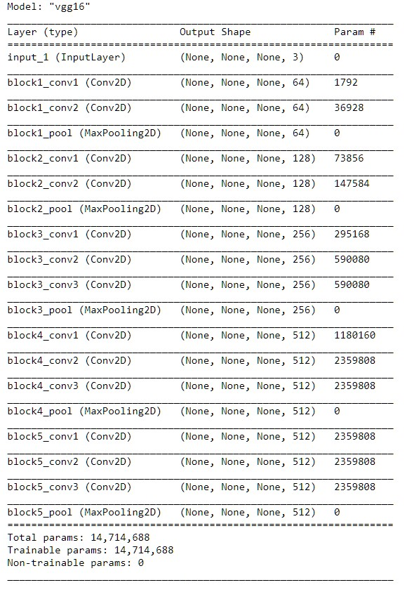

As we can see, we have 14,714,688 trainable parameters when predicting two classes.

Training time increases exponentially with the neural network architecture increasing/deepening. In general, it could take hours/days to train a 3–5 layers neural network with a large-scale dataset. Consequently, deploying VGG from scratch on a large-scale dataset is a tiresome and computationally expensive task due to the depth and number of fully connected layers/nodes in the models’ architecture. Another challenge is that building VGG from scratch requires considerably large memory space and bandwidth since the size of ImageNet trained VGG-16 weights is 528 MB. However, instead of building a VGG from scratch, we can perform transfer learning. Transfer learning is technique to utilize the knowledge of weights and features of previously trained models to solve problems in similar area. For example, we can use transfer learning to a binary image classifier model trained from a pre-trained VGG16 model. To do so we remove the top layers and set all the layers from VGG16 model as untrainable. This will lock the model to use existing training data, and knowledge of known weights. We can now use VGG16 model to extract the features from a given set of training data and pass it on to a different model.

**Sequential Model:**

The Sequential model API is a way of creating deep learning models where an instance of the Sequential class is created, and model layers are created and added to it. A Sequential model is appropriate for a plain stack of layers where each layer has exactly one input tensor and one output tensor.

Dense is a standard deeply connected layer type that works for most use cases. In a dense layer, all nodes in the previous layer connect to the nodes in the current layer. We specify number of neurons per dense layer, and an activation function. When an input shape is specified to the Dense function, an input layer is created and connected to a dense layer created with specified number of neurons.

Activation function constrains the output of a function(neuron) to values between 0 to 1 or -1 to 1. There are two types of activation functions – Linear activation function and Non-linear activation functions. Some examples of activation functions are ReLU, Sigmoid, Tanh, Leaky ReLU etc.

Dropout is a regularization method that approximates training many neural networks with different architectures in parallel. During training, some number of layer outputs are randomly ignored or “dropped out.” This has the effect of making the layer look-like and be treated-like a layer with a different number of nodes and connectivity to the prior layer. In effect, each update to a layer during training is performed with a different “view” of the configured layer. Usually, dropout is placed on the fully connected layers only because they are the one with the greater number of parameters and thus, they're likely to excessively co-adapting themselves causing overfitting. However, since it's a stochastic regularization technique, you can really place it everywhere

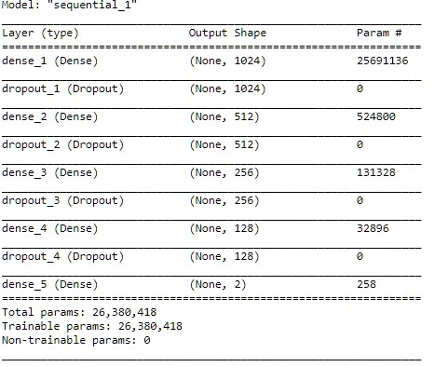

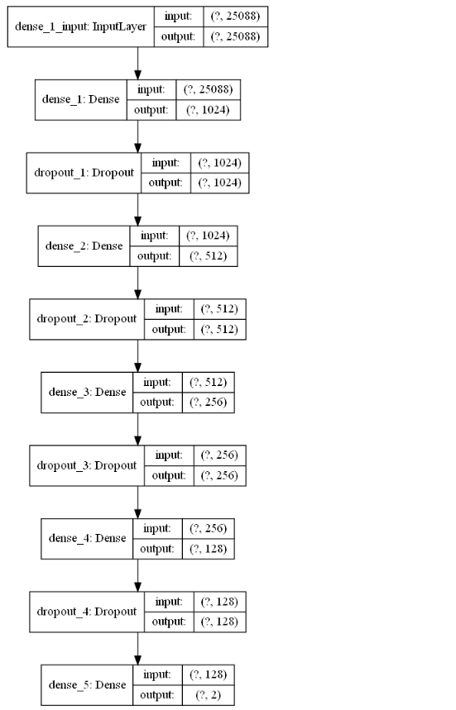

**CNN Model:**

A Convolutional Neural Network is an algorithm that takes an input image and assigns weights and biases to different aspects of the image to distinguish them from each other. The architecture of CNN can be compared to the neuron network in the human brain and was initially inspired by the arrangement of the visual cortex. The behavior of each neuron is defined by the weights assigned to each aspect of the input. [21]

When you input an image into a CNN, each layer generates several activation maps, and activation maps highlight the relevant features of the image input. Further, each neuron takes a patch of pixels as input, multiplies their color value by its weights, and sums them up, running them through the activation function.

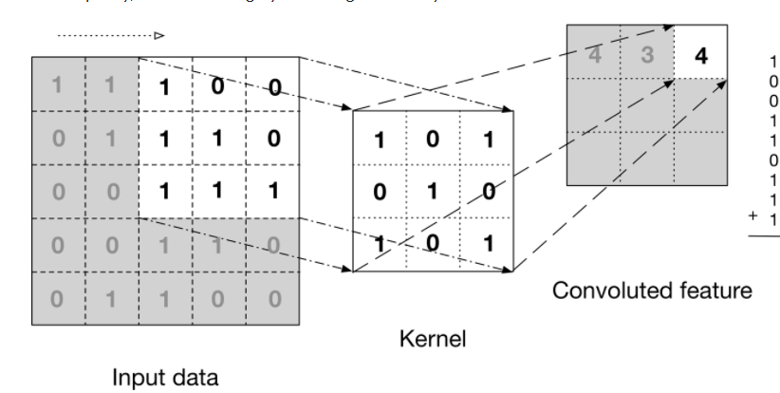

The above image shows what a convolution is. [2]

The first layer in the CNN usually detects basic features like horizontal, vertical edges, and diagonals of the images. As u move in deeper into the convolutional neural network, the layers start fetching objects like faces and more. This processed output is fed as input to the next layer, which further extracts more complex features. Based on the activation map of the final convolution layer, the classification layer outputs a set of confidence scores (values between 0 and 1)[2]

CNN have multiple layers, including convolutional layer, non-linearity layer, pooling layer, and fully connected layer. The convolutional and fully connected layers have parameters, but pooling and non-linearity layers don't have parameters. The CNN has an excellent performance in machine learning problems [3]

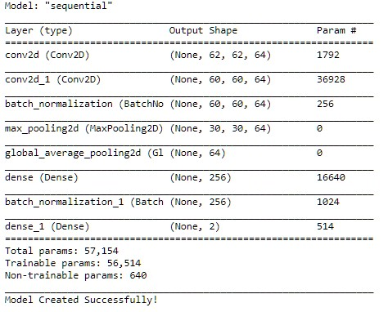

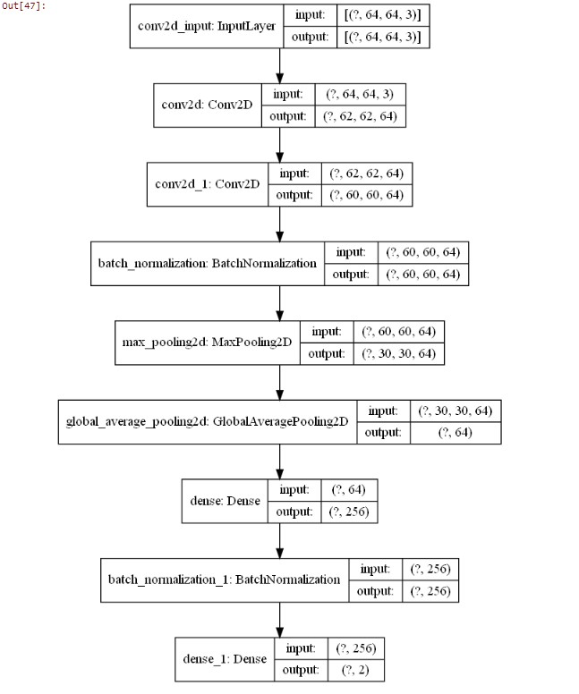

**LSTM Model:**

Long Short Term Memory networks – usually just called LSTMs – are a special kind of RNN, capable of learning long-term dependencies. They were introduced by Hoch Reiter & Schmid Huber (1997), and were refined and popularized by many people in the following work. They work tremendously well on a large variety of problems and are now widely used.

LSTMs are explicitly designed to avoid the long-term dependency problem. Remembering information for long periods of time is practically their default behavior, not something they struggle to learn!

All recurrent neural networks have the form of a chain of repeating modules of neural networks. In standard RNNs, this repeating module will have a very simple structure, such as a single tanh layer.

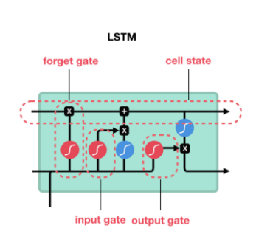



LSTM was created as the solution to short-term memory. They have internal mechanisms called gates that can regulate the flow of information. These gates can learn which data in a sequence is important to keep or throw away. By doing that, it can pass relevant information down the long chain of series to make predictions.

The core concept of LSTM is the cell state and its various gates. The cell state act as a transport highway that carries relevant information down the sequence chain. As the cell state goes on its journey, information gets added or removed via gates. The gates are different neural networks that decide which information is allowed on the cell state, and thus, the gates can learn which data is to be saved and which information to be discarded during training.

the tanh activation function is used squishes the value to be between -1 and 1. When vectors flow through the network, they undergo many transformations due to math operations.

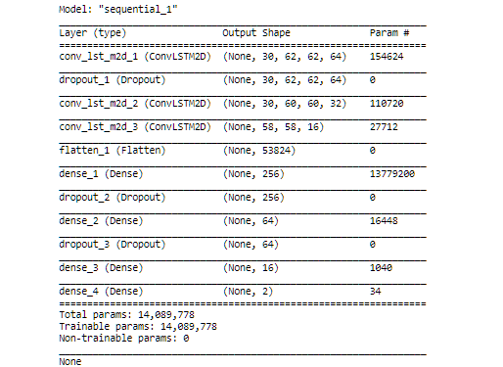

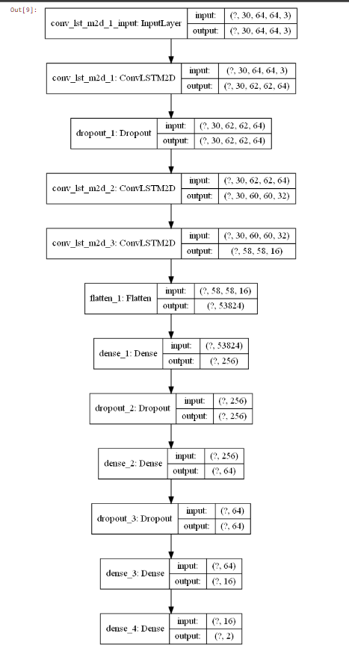

**Potential data challenges & risks in doing the project**

Since in advertisement video annotation we are mainly dealing with video files, so video should have the following characteristics for optimal video processing:

* + The video files should be in valid extensions like .mp4 or .avi files.
  + The video should be in sufficient pace.
  + Need large quality dataset to create and train models, on a particular event.
  + Further improve the image quality in pre-processing steps using techniques like denoising, segmentation, morphology etc.
  + Monotonous video data can overfit the model resulting poor actual event data accuracy.
  + Duplicate data removal may skew the result of event detection.

**Project Resources**

|  |  |  |  |  |
| --- | --- | --- | --- | --- |
| **SNo** | **Phase** | **Resource Type** | **Resource** | **Versions if Applicable** |
| 1 | All | People | Mentor, Faculty, TA, Student |  |
| 2 | All | Hardware / Laptop | 16GB RAM, Windows 10, Intel Core i7 |  |
| 3 | All | Software | Jupyter Notebook  Anaconda  Python  CV2 | 6.1.4  4.8.3  3.8.5  4.3.0 |
| 4 | Collaboration | Software | Google Meet  GitHub repository  WhatsApp  Google Colab | https://github.com/eiensatya7/cap4_group7_va  https://colab.research.google.com/notebooks |

**Detailed Plan of Work**

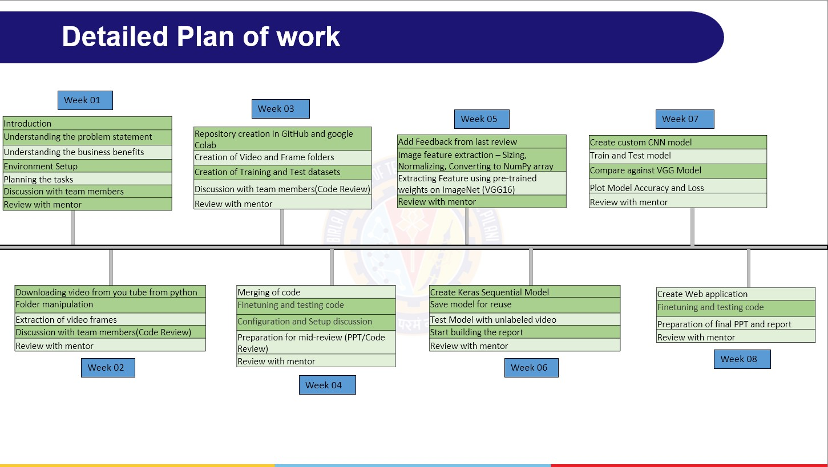

**Code** **Structure and Screenshots**

***Installation Steps:***

Please refer to “requirement.txt”: to define the required package and version used in the project.

***Structure:***

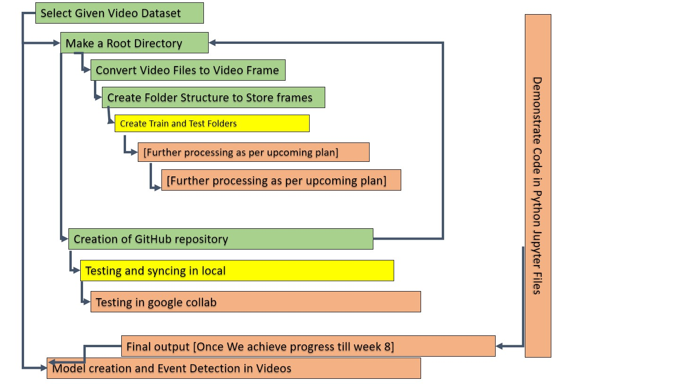

**Folder Structure:**

**.**

├── AD-VDO ← Folder having all video reside in this folder.

├── Audio ← Extracted video is stored in audio folder.

│ └── processed ← After process the audio, we get the clean processed audio.

├── Extracted Text

├── images ← Bits logs

├── main module

├── model weights ← Model weights for image processing(YOLO3/YOLO4)

│ ├── yolo_v3

│ └── yolo_v4

├── Object Detection ← Finally Object detected result set

├── utilities ← Having all python utility code.(having .py file)

│ └── __pycache__

└── VDOFrames ← Image frame extracted from video for OCR

└── VDO-AD-200 ← Based on video-file name(VDO-AD-200) it will create folder

├── grayscale ← having all image frame related to grayscale.

├── grayscale_scaled

└── scaled

**Code Structure:**

step 0:

Filename: PCAMZC321_Group5_VIDEOANALYTICS_PreProcessing_Step-0. ipynb

Downloading and storing video from You Tube

creating folder and subfolder

video to frame conversion

blur and duplicate detection

pre-processing and storing frames (although only being used in first model)

step 1:

VGG Model

File Name: - PCAMZC321_Group5_VIDEOANALYTICS_VGG16SequentialModelTraining_Step-1.iypnb

creating the base model of pre-trained VGG16 model

Keras Neural Network Sequential Model

Training the video classification model

Evaluate trained model on the feature’s and label’s test sets

step 2:

File Name: - PCAMZC321_Group5_VIDEOANALYTICS_VGG16SequentialModelOutputVideoCreation_Step-2.iypnb

Applying model on VDO having no class

Constructing The Output YouTube Video Path

Event Prediction

Save prediction

Predict on Live Videos

step 3:

CNN model

File Name: -PCAMZC321_Group5_VIDEOANALYTICS_CNNModelandVideoCreation_Step-3. iypnb

Extract, Resize and Normalize Frames

Dataset Creation

Constructing the Model

Compile and Train the Model

Evaluating Trained Model

create Video

step 4:

LSTM model

File Name: - PCAMZC321_Group5_VIDEOANALYTICS_LSTMModelandVideoCreation_Step-4. iypnb

Creating frames from videos

creating model

load the model from disk

model_evaluation_loss, model_evaluation_accuracy

**Output Snapshot**

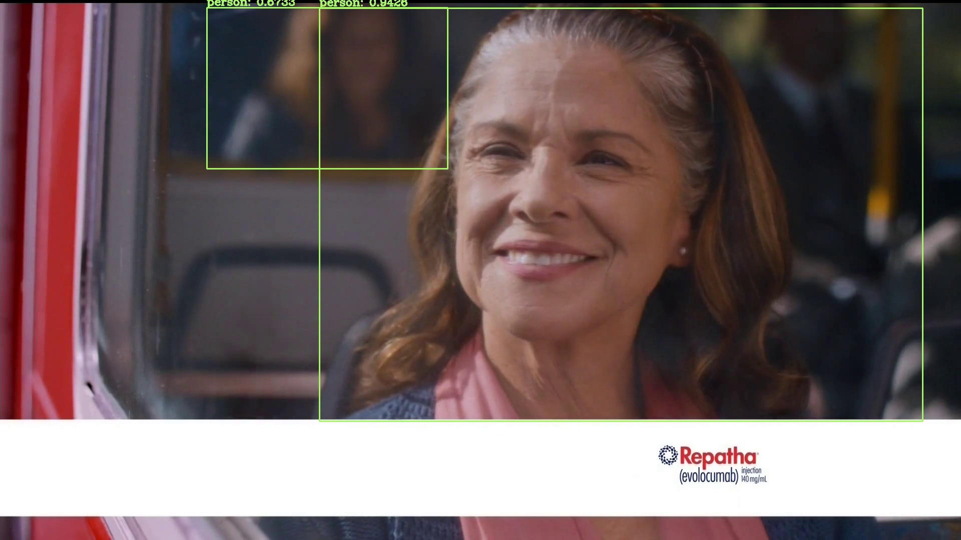

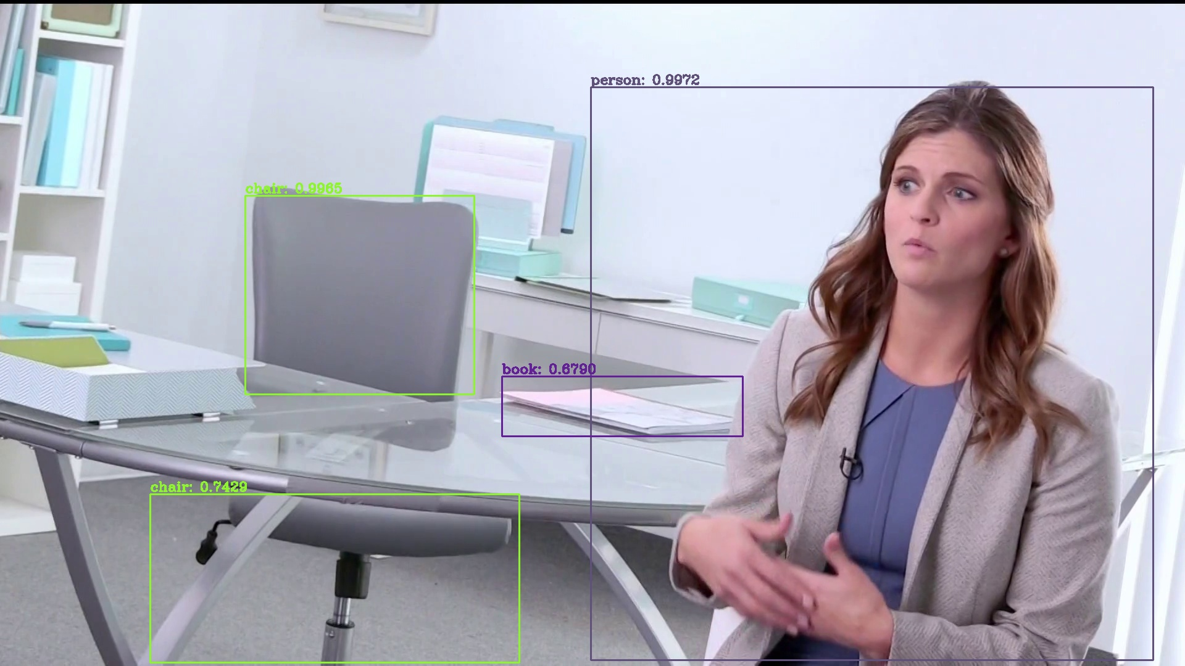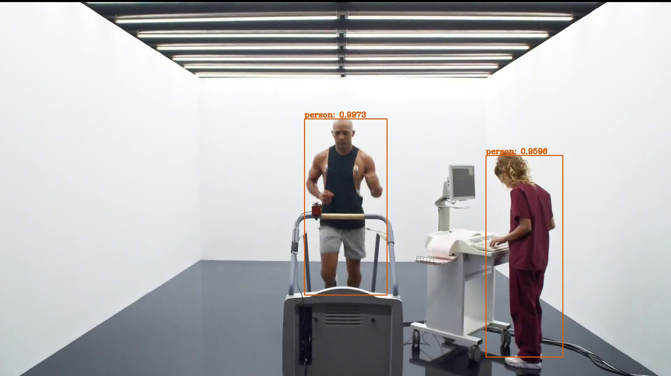

**Interpretation**

* CSV generation on extracted frames

|  |  |  |  |
| --- | --- | --- | --- |
|  | Frame Filename | Full Path Name | class |
| 0 | MoreBasketBallVdo.mp4 | C:/1-GG/CAP4/EventDetection/1-ExampleSetting\V... | Basketball |
| 1 | MoreBasketBallVdo.mp4 | C:/1-GG/CAP4/EventDetection/1-ExampleSetting\V… | Basketball |
| 2 | MoreBasketBallVdo.mp4 | C:/1-GG/CAP4/EventDetection/1-ExampleSetting\V… | Basketball |
| 3 | MoreBasketBallVdo.mp4 | C:/1-GG/CAP4/EventDetection/1-ExampleSetting\V… | Basketball |
| 3 | MoreBasketBallVdo.mp4 | C:/1-GG/CAP4/EventDetection/1-ExampleSetting\V... | Basketball |

* Comparing Models

Accuracy charts for CNN , VGG and LSTM models

1. CNN model accuracy chart 2. VGG model accuracy chart

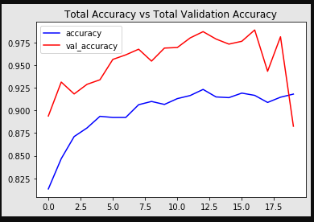 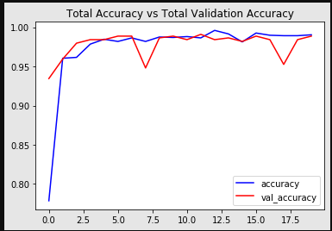

3. LSTM model accuracy chart

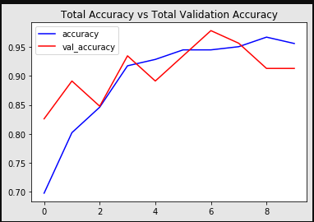

Loss charts for CNN, VGG, LSTM models

1.Loss chart for CNN Model 2.Loss chart for VGG model

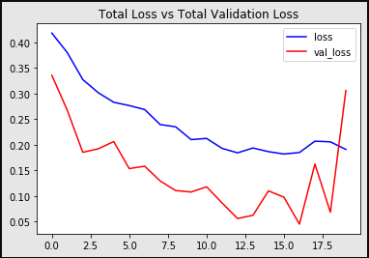 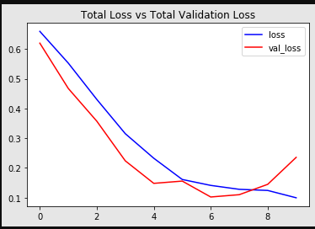

3. Loss chart for LSTM model

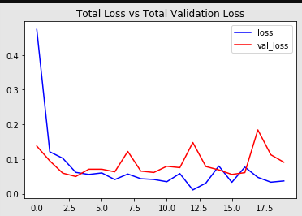

**Conclusions / Recommendations**

**How to get rid of overfitting.**

**If we have more activity, we need to check how model performs, especially in LIVE video cases.**

In this project we have presented how machine learning models such as VGG16, Custom sequential models, CNN and LSTM model can be used to perform event detection in video data. We have seen video data is like image data except additional time dimension.

**Future Work & Extension or Scope of improvements**

**Add more preprocessing**

**Live video**

**Future Scope:**

1) Audio noise Reduction: use noise reduction technique from deep learning).

2) Logo Detection: (Rule based; Logo can be present besides company name).

3) Design frontend video upload functionality and store videos and images at some cloud and visualization of 360view to video. (with react and expose api for visualization).

4) Topic modelling.

5) Sentiment Analysis.

6) Object detection using GAN, CNN and encoder and decoder and other (using Generative Adversarial Network).

**Bibliography / References**

1. Albawi, S., Mohammed, T. and Al-Zawi, S., 2017. Understanding of a convolutional neural network. *2017 International Conference on Engineering and Technology (ICET)*,.
2. Rahman, L., Mohammed, N. and Al Azad, A., 2016. A new LSTM model by introducing biological cell state. *2016 3rd International Conference on Electrical Engineering and Information Communication Technology (ICEEICT)*,.
3. Yu, Y., Si, X., Hu, C. and Zhang, J., 2019. A Review of Recurrent Neural Networks: LSTM Cells and Network Architectures. *Neural Computation*, 31(7), pp.1235-1270.

4. Aljarrah, I. and Mohammad, D., 2018. Video content analysis using convolutional neural networks. *2018 9th International Conference on Information and Communication Systems (ICICS)*,.

5.Simonyan, K., 2021. *Very Deep Convolutional Networks for Large-Scale Image Recognition*. [online] ResearchGate. Available at: <https://www.researchgate.net/publication/265385906_Very_Deep_Convolutional_Networks_for_Large-Scale_Image_Recognition> [Accessed 5 November 2021].

Other link:

1.Analytics Vidhya. 2021. *CNN for Deep Learning | Convolutional Neural Networks*. [online] Available at: <https://www.analyticsvidhya.com/blog/2021/05/convolutional-neural-networks-cnn/> [Accessed 4 November 2021].

1. Dickson, B., 2021. *What are convolutional neural networks (CNN)?*. [online] Tech Talks. Available at: <https://bdtechtalks.com/2020/01/06/convolutional-neural-networks-cnn-convnets/> [Accessed 4 November 2021].

Appendix :

Jupyter Scripts:

* Program names with one line describing what that code does

Coursecode name_ (file name)

**Abbreviations**

VGG : Visual Geometry Group (Oxford)

CNN : Convolution Neural Network

LSTM : Long Short-Term Memory

ReLU :

**Checklist of items for the Final report**

1. Is the Cover page in proper format? Y
2. Is the Title page in proper format? Y
3. Is the Certificate from the Mentor in proper format? Has it been signed? Y
4. Is Abstract included in the Report? Is it properly written? N
5. Does the Table of Contents page include chapter page numbers? N
6. Does the Report contain a summary of the literature survey? Y
   1. Are the Pages numbered properly? Y
   2. Are the Figures numbered properly? Y
   3. Are the Tables numbered properly? Y
   4. Are the Captions for the Figures and Tables proper? Y
   5. Are the Appendices numbered? Y
7. Does the Report have Conclusion / Recommendations of the work? Y
   * 1. Are References/Bibliography given in the Report? Y
     2. Have the References been cited in the Report? Y
     3. Is the citation of References / Bibliography in proper format? Y

**Note: A copy of this checklist should be included as the last page of the Final report. This checklist, duly completed and signed by the student, should also be verified and signed by the evaluators. Evaluators are requested to ensure that the students have submitted their reports properly.**